Power BI

Power BI is a [business intelligence tool](https://www.datacamp.com/blog/top-business-intelligence-tools) that allows you to connect to various data sources, visualize the data in reports and dashboards, and then share them with anyone you want.

Power BI is made up of 3 main elements:

1. Power BI Desktop - a free desktop application for building and designing reports.
2. Power BI Service - the online publishing service for viewing and sharing reports and dashboards.
3. Power BI mobile apps - for viewing reports and dashboards on the go.

**What is Power BI Used For?**

Power BI is a tool in the category of Business Intelligence (BI). The purpose of BI is to track Key Performance Indicators (KPIs) and uncover insights in business data so as to better inform decision-making across the organization.

Power BI is used in different ways depending on the role of the individual, from developers, analysts, managers, and directors, to everyone in between.

**Overview:**

When you launch the application, Power BI will start with a blank report. Let's go over the components of the Power BI Desktop:

* Ribbon - the top ribbon contains most of the controls and options needed for building the report.
* Views - this is made up of the report view, the data view, and the model view.
* Canvas - this is the main design area where visualizations and other elements are added.
* Page selector - for navigation to other pages in the report.
* Filters - fields can be added here to filter the data.
* Visualizations - this contains the list of available visualizations.
* Fields - this section contains the tables and fields that are available in the data model.

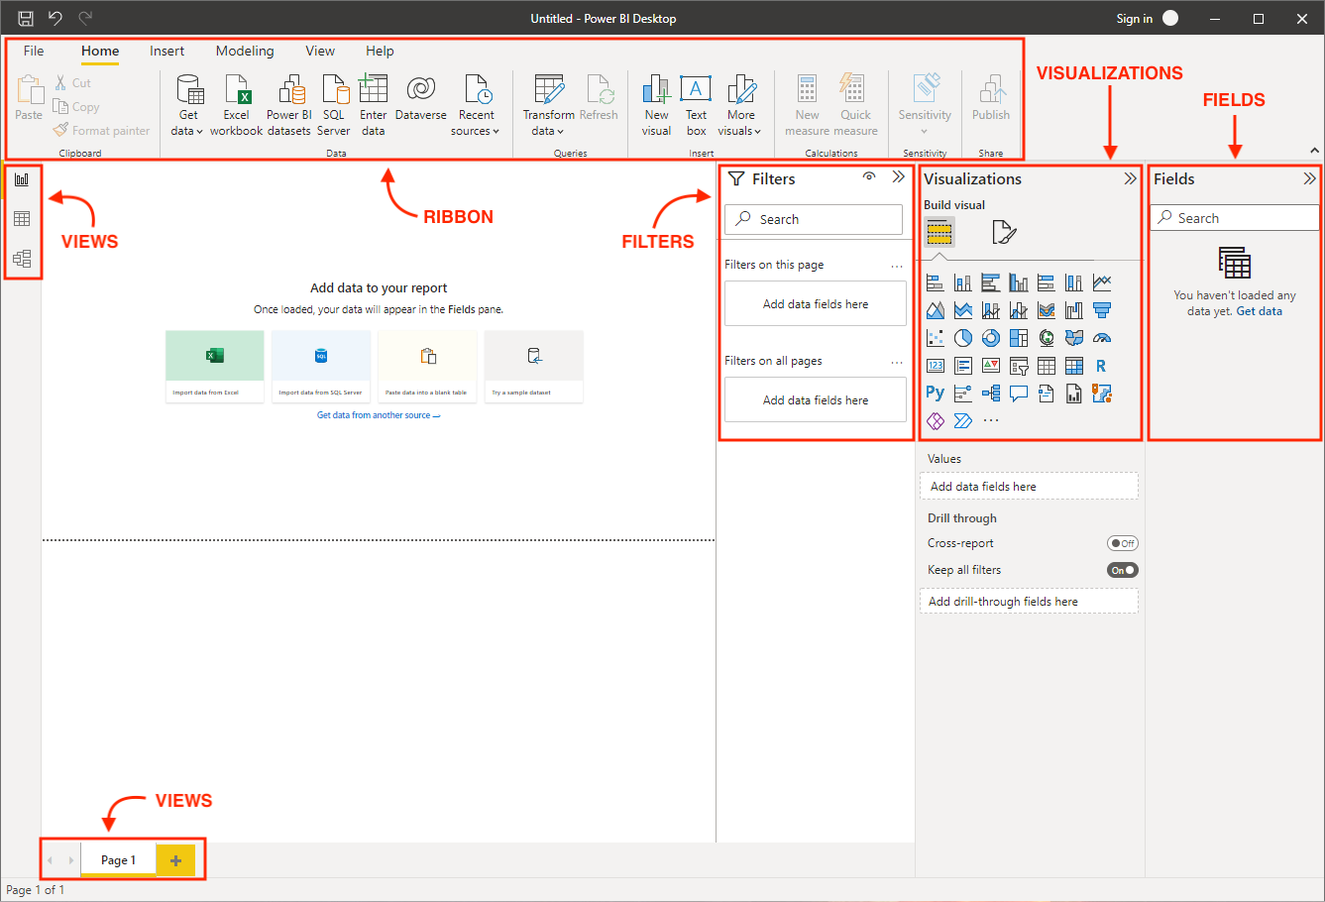

## Importing and Transforming Data in Power BI Desktop

### **Data Sources and Connections**

Power BI offers a plethora of supported data sources and connections. This makes it incredibly easy to connect to the data source of your choosing.

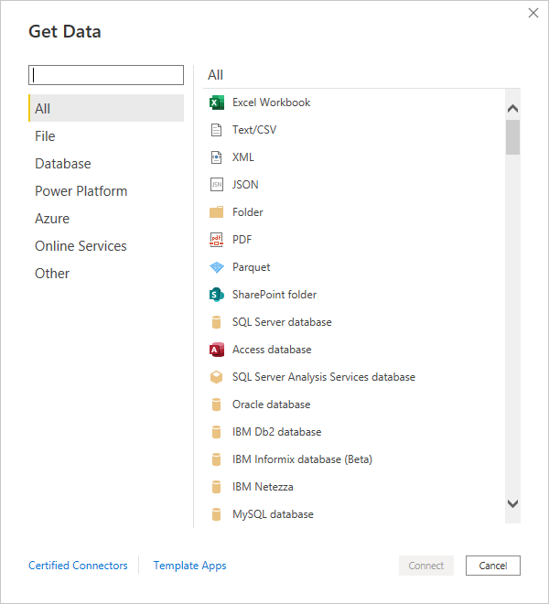

### **Importing Data**

You can download the [sample data](https://docs.microsoft.com/en-us/power-bi/create-reports/sample-financial-download) and import it by selecting the Excel data source.

A preview window will pop up where you can select the table or sheet you want to import from the Excel file. Tables and sheets are designated by their respective icons. It is generally better to import tables as they are neatly defined in Excel with strict headers and row boundaries.

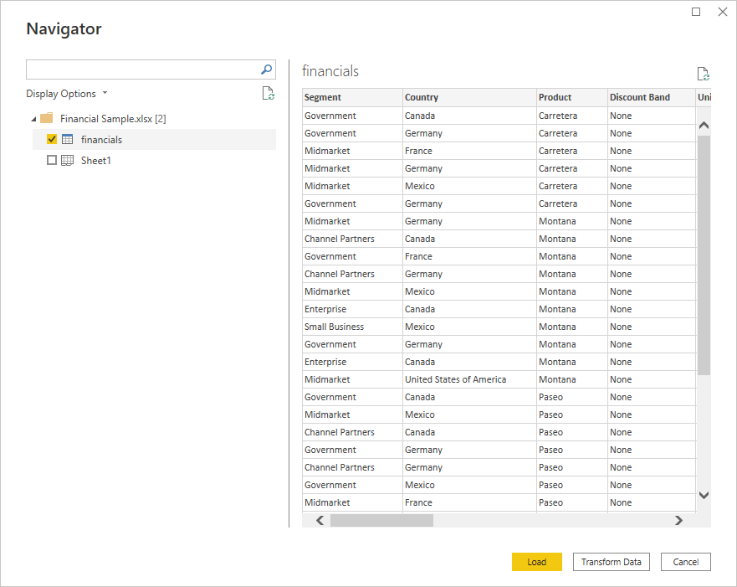

Here you can also choose whether to load the data directly or go straight to the Power Query Editor using the Transform Data option. Choosing to first transform your data before loading it in can be advantageous as there are often little errors and issues that you may want to iron out first. Select Transform Data and a separate window will open up for the Power Query Editor.

### **Power Query**

The Power Query Editor can be broken up into 4 main parts:

* Ribbon - the top ribbon contains almost all of the data transformation options you need to shape your data. We will explore a few common transformations below.
* Queries - this lists all the queries you have set up for this report. For complex reports, you can organize queries into groups for better navigation and management.
* Data view - this is the main table containing the data for the selected query as well as a formula bar. A preview of the data is shown with only the first 1000 rows.
* Transformation steps - the right-hand pane contains each of the transformation steps that have been applied to the selected query. This allows you to keep track of each individual change that has been made to the data. You can insert, delete, and move steps around as needed.

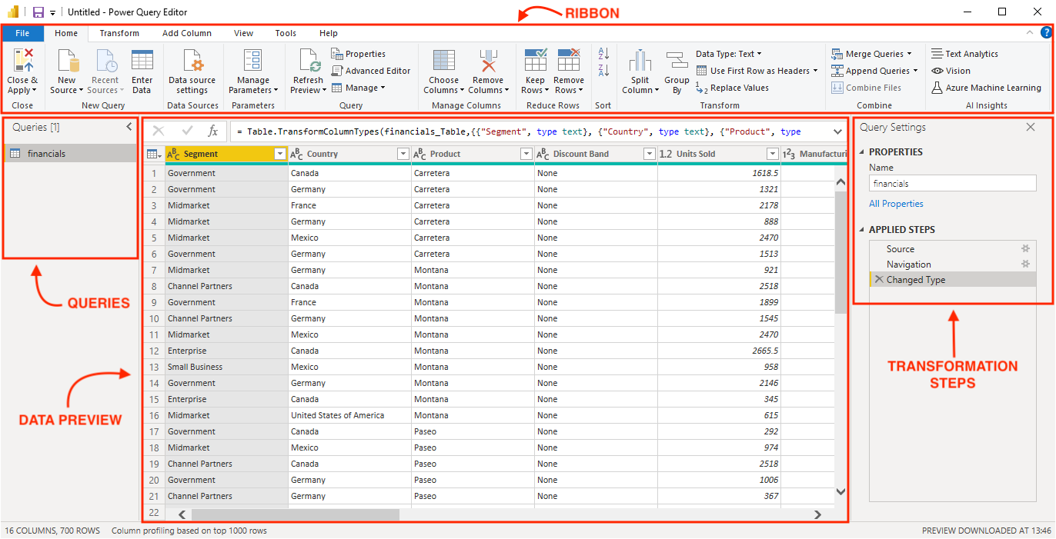

Here, the financial sample data is already very clean so there are no transformation steps for us to apply. However, these are some of the most common transformation steps:

* Removing rows and/or columns - some Excel data can have a lot of blank rows and/or columns inserted for readability and aesthetic purposes, but these are not useful in Power BI and should be removed.
* Changing data types - data types such as number, date, or text should be specified for each column. Power BI will try to automatically detect the data type, yet it can sometimes be wrong or there can be errors so it is a good idea to always double-check the data types.
* Combining data with merge and append - similar to join and concatenate in SQL, these transformations allow you to combine queries from multiple sources.
* Pivot and unpivot - these options allow you to transform your data from a wide to a long format and vice versa. The unpivot option is particularly useful when dealing with Excel files that have information (such as dates) running across the columns of a table rather than as rows.
* Adding a conditional column - this is a useful transformation that allows you to add a column based on if/then/else logic.

In the below example, we have included an additional table called “products”, containing some fictitious product categories so that data modeling can be demonstrated later in this tutorial. You can add this table by selecting Enter Data in the ribbon.

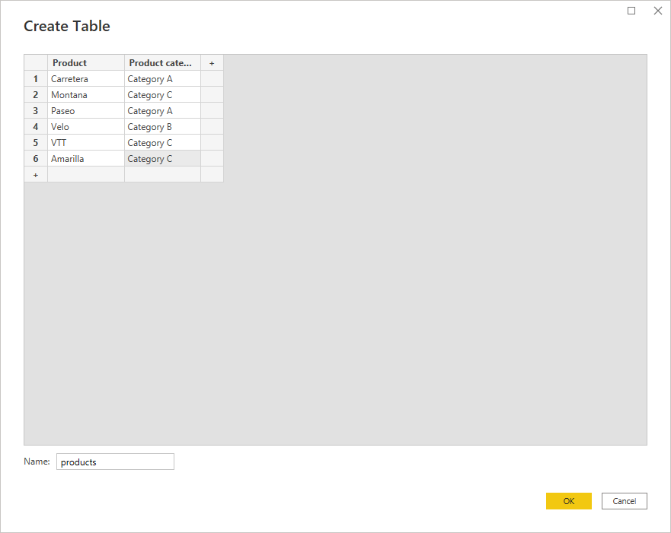

Lastly, select Close & Apply from the ribbon to get started with building and designing the report.